Create 2 EC2 instances on 2 different regions and install nginx using terraform script.

Create AWS EC2 using Terraform

Amazon EC2 is a web service presented by Amazon Web Services (AWS) that gives resizable compute capacity in the cloud. It permits clients to run virtual servers, known as EC2 instances, in a versatile and flexible manner. EC2 instances can be handily provisioned and designed to meet changing jobs, making them suitable for a wide range of applications.

Key Features of Amazon EC2

Scalability: You can easily increase or decrease the number of instances based on demand.

Instance Types: Choose from compute-optimized, memory-optimized, or storage-optimized instance types that are optimized for various use cases.

AMI (Amazon Machine Image): Launch instances with particular software and operating system configurations by utilizing pre-configured images.

Elastic Load Balancing: Circulate approaching traffic across different examples to ensure high accessibility and adaptation to non-critical failure.

Terraform

Terraform is an open-source Infrastructure as Code (IaC) apparatus created by HashiCorp. It empowers clients to characterize and arrange foundations utilizing a revelatory setup language. With Terraform, clients can oversee assets across numerous cloud suppliers, including AWS, Sky Blue, and Google Cloud Stage, as well as on-premises conditions.

Key Features of Terraform

Declarative Configuration: Depict the ideal infrastructure state in a configuration file (written in HashiCorp Design Language - HCL).

Support for Multi-Clouds: Arrangement and oversee assets across different cloud suppliers with a solitary arrangement of design documents.

Version Control: Infrastructure code can be formed, permitting joint effort and change following.

Dependency management: The order of resource creation and their interdependencies are automatically managed by Terraform.

Plan and Apply: Terraform gives an planning phase (terraform plan) to review changes prior to applying them (terraform apply).

Now install and configuring Terraform

Go to browser and search for terraform official site in that official site is there terraform download link as shown in below commands and Open a terminal or command prompt and run the command terraform version to verify the installation.

sudo yum install -y yum-utils shadow-utils
sudo yum-config-manager --add-repo https://rpm.releases.hashicorp.com/AmazonLinux/hashicorp.repo
sudo yum -y install terraform

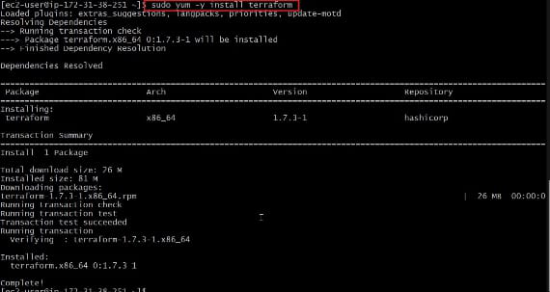

Now after installed and configured terraform, Now make a new directory and navigate to it, Terraform file must should be save with filename.tf.

Additional files can be created to modularize your code or to store provider-specific configurations. You will define the infrastructure resources you want to create in the main.tf file, such as VPCs, subnets, security groups, and AWS EC2 terraform instances.

Terraforms declarative language is used to define each resource, allowing you to declare the desired state of the resource.

Authentication with AWS

Go to AWS Management Console.

Login with by using your credentials.

Now you need to generate access key to authenticate Terraform with your AWS account.

In AWS management console in home screen search for IAM ( Identity and Access Management ) service. Choose Users and click on Add user.
Give a username and select administration access as the access type. Attach necessary permissions to the user.

Review the user details and create the user. Now you will see the access key ID and secret access key. Save this information securely as it will be required when configure Terraform.

Create an EC2 instance using Terraform configuration files

Now that we have the networking infrastructure and security groups set up, let’s define the EC2 terraform instance itself. Here’s an example:

resource "aws_instance" "my_instance" {
ami = var.ec2_ami
instance_type = var.ec2_instance_type
subnet_id = aws_subnet.my_subnet.id
vpc_security_group_ids = [aws_security_group.my_sg.id
tags = {
Name = "my-ec2-instance"
}
}

In the above code, we define an AWS EC2 terraform instance resource with the specified AMI (Amazon Machine Image), instance type, subnet, and security group. Also, we assigned a tag to the instance for identification.

Terraform block it was describe the cloud required version and the required credentials. The following example shows that aws provider:

terraform {
required_providers {
aws = {
source = "hashicorp/aws"
version = "~> 4.16"
}
}
required_version = ">= 1.2.0"
}
provider "aws" {
region = "us-west-2"
profile = "jack.roper"
}
resource "aws_instance" "example_server" {
ami = "ami-04e914639d0cca79a"
instance_type = "t2.micro"
tags = {
Name = "JacksBlogExample"
}
}

VPC (Virtual Private Cloud) is isolated section in aws cloud where your resources can be launched. We can create VPC by using terraform.

For example to creating a VPC and Subnet, you would define a resource block like this:

resource "aws_vpc" "sada" {
cidr_block = "10.0.0.0/16"
instance_tenancy = "default"
tags = {
Name = "siva"
}
}

In this example, we specify the vpc with cidr block, subnet ID, and tags for the EC2 instance.

Terraform will use this configuration to create the specified EC2 instance when you apply the configuration.

# provider block defines the cloud provider and its configuration
provider "aws" {
region = "us-east-1"
}
# variable block allows you to define variables for reusability
variable "instance_type" {
description = "Type of EC2 instance"
default = "t2.micro"
}
variable "ami" {
description = "Amazon Machine Image ID"
default = "ami-12345678"
}
# resource block defines the AWS resources to be created
resource "aws_vpc" "my_vpc" {
cidr_block = "10.0.0.0/16"
# other VPC configurations...
}
resource "aws_security_group" "my_security_group" {
vpc_id = aws_vpc.my_vpc.id
# other security group configurations...
}
resource "aws_instance" "my_instance" {
ami = var.ami
instance_type = var.instance_type
subnet_id = aws_subnet.my_subnet.id
security_group = [aws_security_group.my_security_group.id]
# other instance configurations...
}
resource "aws_subnet" "my_subnet" {
vpc_id = aws_vpc.my_vpc.id
cidr_block = "10.0.1.0/24"
availability_zone = "us-east-1a"
map_public_ip_on_launch = true
# other subnet configurations...
}
# output block allows you to define values to be displayed after apply
output "instance_ip" {
value = aws_instance.my_instance.public_ip
}

Providers Block

Providers block is utilized to design the Providers, which is liable for overseeing assets in a particular cloud environment (e.g., AWS, Azure, and so on.).

It remembers subtleties, for example, the district for which assets ought to be made.

Variable Block

Input variables that can be used throughout your Terraform configuration can be defined using the variable block.

Helps in defining your design and making it more adaptable.
You can set default values, depictions, and different qualities for factors.

Resource Block

Resource block is the most key structure block in Terraform.

It proclaims an asset type (e.g., aws_instance, aws_vpc) and its particular setups.

Every asset block makes an occurrence of the asset it depicts.

Output Block

Output block characterizes values that will be displayed subsequent to applying the Terraform arrangement.

Valuable for showing data like IP addresses, DNS names, and so on.
Gives a method for uncovering explicit data for outside use

Infrastructure as Code (IaC) is a method that permits you to oversee and arrangement foundation assets utilizing code instead of manual cycles. Terraform, being an IaC device, empowers you to characterize your framework in a definitive language and keep up with it as rendition controlled code. Let's learn how to set up an AWS EC2 terraform instance and write infrastructure as code using Terraform.

Configuring Security Groups, Security is most important due to it acts as a virtual firewalls, its controlling inbound and outbound traffic for your AWS EC2 terraform instance.

resource "aws_security_group" "my_sg" {
name = "my-security-group"
description = "Allow inbound SSH and HTTP traffic"
inbound {
from_port = 22
to_port = 22
protocol = "tcp"
cidr_blocks = ["0.0.0.0/0"]
}
inbound {
from_port = 80
to_port = 80
protocol = "tcp"
cidr_blocks = ["0.0.0.0/0"]
}
outbound {
from_port = 0
to_port = 0
protocol = "-1"
cidr_blocks = ["0.0.0.0/0"]
}
}

Initialize the Terraform directory

Now it's time to Initializing and applying the terraform configuration after writing the terraform code code by using following code:

terraform init

When using Terraform, the terraform init command is a crucial step. It initializing a working directory, setting up the fundamental parts for Terraform to collaborate with the specified backend (like AWS,Azure , or local), and download any expected supplier modules.

Run terraform plan and apply

To apply the terraform configuration and create the EC2 terraform instance, to run the following command:

terraform apply

Cleaning up and destroying AWS resources is a fundamental stage to prevent unnecessary costs and keep a clean infrastructure. This is the way you can tidy up the assets made by your AWS EC2 terraform example.

Create an EC2 instance with user_data

Define your Terraform configuration: Create a .tf file, for example, ec2_instance.tf, and define your EC2 instance configuration along with user data:

provider "aws" {
region = "your_aws_region"
}
resource "aws_instance" "example" {
ami = "your_ami_id"
instance_type = "t2.micro"
key_name = "your_key_pair_name"
security_groups = ["your_security_group_name"]
subnet_id = "your_subnet_id"
user_data = <<-EOF
#!/bin/bash
# Update package repositories
apt-get update -y
# Install nginx
apt-get install nginx -y
# Start nginx service
systemctl start nginx
# Enable nginx to start on boot
systemctl enable nginx
EOF
}

Here is the Terraform code to create the ec2 instance on the aws.

Here is the aws Instance created on the aws console.

Here is the system log the userdata commands executed while creating the container.

The service status of the nginx was successfully running on the instance.

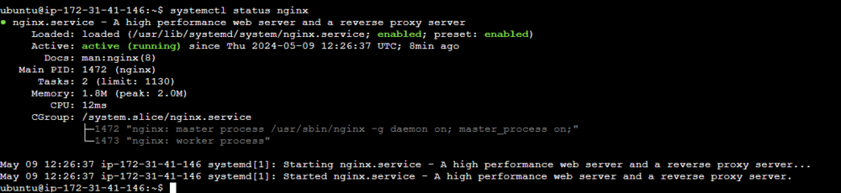

Accessed the nginx using the IP of the address.

Create Multiple EC2 Instances With Different Configurations

To create multiple EC2 instances with different configurations using Terraform, you can define multiple instances within your Terraform configuration, each with its own set of parameters. Here's an example:

provider "aws" {
region = "your_aws_region"
}
# Define the first EC2 instance
resource "aws_instance" "instance1" {
ami = "ami-xxxxxxxx" # AMI ID for the first instance
instance_type = "t2.micro"
key_name = "your_key_pair_name"
security_groups = ["your_security_group_name"]
subnet_id = "your_subnet_id"
# User data script for the first instance
user_data = <<-EOF
#!/bin/bash
# User data commands for the first instance
EOF
}
# Define the second EC2 instance
resource "aws_instance" "instance2" {
ami = "ami-yyyyyyyy" # AMI ID for the second instance
instance_type = "t2.nano"
key_name = "your_key_pair_name"
security_groups = ["your_security_group_name"]
subnet_id = "your_subnet_id"
# User data script for the second instance
user_data = <<-EOF
#!/bin/bash
# User data commands for the second instance
EOF
}
# Define more instances as needed...

Terminating the EC2 Occurrence

As referenced before, terminating the terraform EC2 instance will remove it for all time, including any related storage and data. Make a point to take backups if necessary prior to terminating the instance.

Removing Terraform Resources: Removing command is necessary in order to ensure that all Terraform resources are properly destroyed. This order will dissect the Terraform state and eliminate every one of the assets oversaw by Terraform, including the VPC, subnet, security groups, and some other resources defined in your Terraform setup.

Run the following command in the directory where terraform project is located

terraform destroy

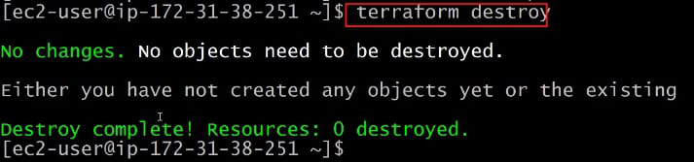

How To Install Nginx On Amazon linux ?

Nginx, at first conveyed in 2004 by Igor Sysoev, is a decent open-source web server, switch go-between, load balancer, and HTTP store. With its occasion-driven planning, Nginx productively handles endless simultaneous affiliations, making it ideal for high-traffic districts and applications.It keeps up with taking care of static and dynamic substance, lessening the heap on backend servers and further making reaction times for regularly got to assets. Nginx besides gives fiery TLS/SSL end limits, supporting current web shows like HTTP/2 and WebSocket for speedier and more helpful correspondence among clients and servers.

What is Nginx?

Nginx is a famous, popular open-source web server, switch intermediary server, load balancer, and HTTP store. It's known for its elite performance, versatility, and reliability, making it extensively used for serving web content and directing web traffic.

Installation Of Ngnix on Amazon Linux:

Step 1: Launch An Instance

Launch EC2 Instances with specifications AMI amazon Linux 2 kernel, AMI Ubuntu 20.4

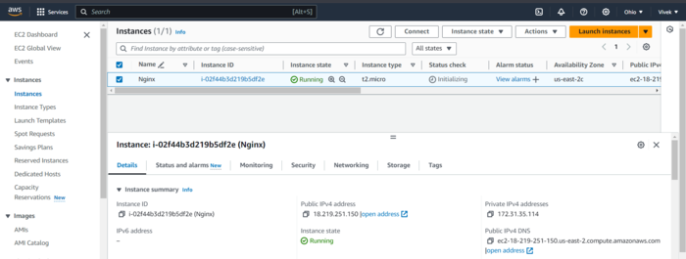

Step 2: Connect To Instance.

Now, connect it to the instance with SSH command.

ssh -i "WP.pem" ec2-user@ec2-18-219-251-150.us-east-2.compute.amazonaws.com

With the help of the above command, we can connect to the instance using different terminals like GitBash, Command Prompt, etc..

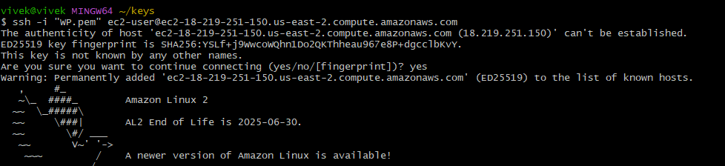

Step 3: Install Nginx

On running the following commands you can install the Nginx. The following update the existing softwares.

Sudo yum update

The following install the nginx software:

sudo amazon-linux-extras install nginx1.12

With the help of the above command, we can update all the existing packages, Installing nginx into the server.

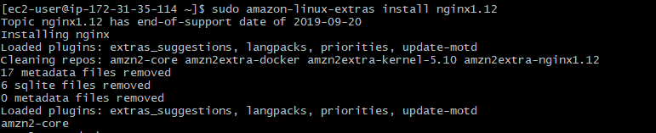

Step 4: Start The Nginx Server

Start, enable and check the status of the Nginx using the commands.

sudo systemctl start nginx
sudo systemctl enable nginx
sudo systemctl status nginx

With the help of the above command, we can Start, enable and check the Status of the Nginx.

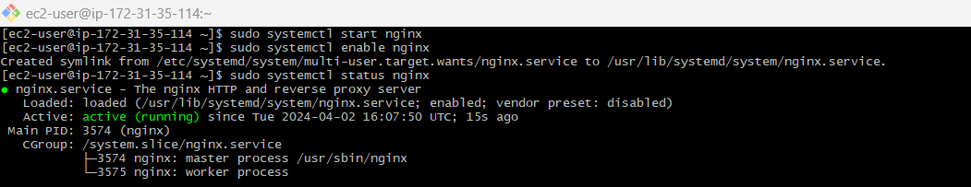

Step 5: Check Nginx Service Status

Check the Nginx is Installed or not from terminal. The following command helps in checking the status of the nginx server:

systemctl status nginx

Withe the help of the above command, we can check nginx server is installed or not, nginx service is running or not.

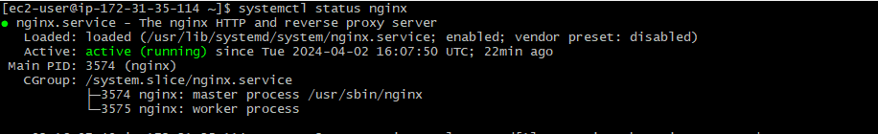

Step 6: Copy Instance Public IP

Now, copy and paste the Public IP address of the instance and browse it see the official landing page of the Nginx.

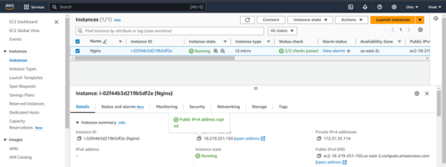

Result

The following screenshot illustrates the successful running of the Nginx Server:

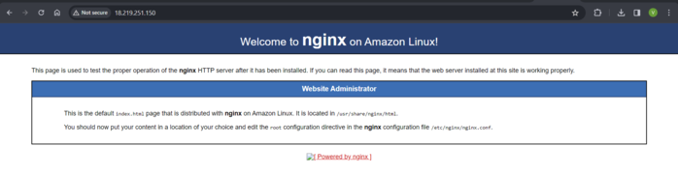

Terraform Work Flow

Terraform is an open-source infrastructure as code (IaC) tool developed by HashiCorp. It enables you to define, provision, and manage your infrastructure resources across various cloud providers and on-premises environments in a declarative manner.

With Terraform, you can describe your desired infrastructure state using a declarative configuration language (HCL - HashiCorp Configuration Language). The configuration files define the resources, their properties, and the relationships between them. This allows you to treat your infrastructure as code, providing version control, collaboration, and repeatability benefits.

Terraform supports a wide range of cloud providers, including Amazon Web Services (AWS), Microsoft Azure, Google Cloud Platform (GCP), and many others. It also supports managing resources in on-premises environments and various other services such as DNS providers, content delivery networks (CDNs), and databases.

Terraform workflow

1. Define Infrastructure

Create a directory for your Terraform project and define your infrastructure using Terraform configuration files. These files describe the desired state of your infrastructure resources, such as virtual machines, networks, databases, and more. The main configuration file is usually named main.tf, but you can split the configuration across multiple files as needed.

2. Terraform Initialize

In the project directory, run Terraform init to initialize Terraform. This command downloads the necessary provider plugins and sets up the backend configuration. The backend configuration determines where Terraform stores its state file, which tracks the current state of your infrastructure. Now run terraform init command in the terminal as shown in the figure below.

terraform init

2. Terraform Validate

The Terraform validate command is used to validate the syntax and configuration of your Terraform files without actually applying or modifying any infrastructure.

It performs a static analysis of your code and checks for any errors or warnings in the configuration.

To use the Terraform validate command, navigate to the directory containing your Terraform files and execute the following command:

Terraform validate

Here are the typical outcomes of running terraform validation:

If your Terraform configuration is valid and error-free, the command will exit with a success message, indicating that the configuration is syntactically correct.

If there are any syntax errors or issues in your Terraform files, the command will display specific error messages pointing to the problematic lines or elements in your configuration.

Example output:

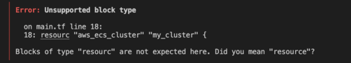

3. Terraform Plan

Run terraform plan to create an execution plan. This command analyzes your configuration and compares it with the current state, identifying the changes necessary to achieve the desired state. It provides an overview of what resources will be created, modified, or deleted. Now add terraform plan command you will see the execution plan by terraform.

terraform plan

4. Terraform Apply

Use Terraform apply to execute the plan and apply the changes to your infrastructure. Terraform prompts for confirmation before proceeding. Once confirmed, it provisions the resources according to your configuration and updates the state file. Now run terraform apply command you will see this as output and with a resource that you have mentioned.

5. Review and Iterate

After applying the changes, review the resulting infrastructure. You can validate that the resources were created correctly and are functioning as expected. If necessary, iterate on your configuration by making modifications to the Terraform files and repeating steps 3 to 5.

6. Terraform Destroy

When you want to tear down the infrastructure, use Terraform destroy. This command reads the state file and destroys all the resources managed by Terraform. It's important to exercise caution with this command as it permanently deletes resources.

Throughout the workflow, it's crucial to maintain the Terraform state file, which tracks the current state of your infrastructure. This file should be stored securely and version-controlled to ensure consistency and facilitate collaboration.

Additionally, you can use other Terraform commands and features as needed, such as Terraform validate to check your configuration for syntax errors, terraform state to interact with the state file directly, and modules to organize and reuse infrastructure code.

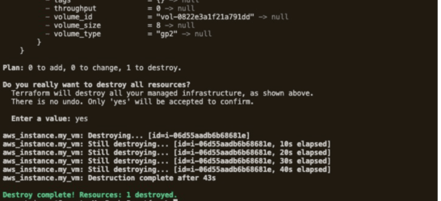

Terraform Validate Command

Terraform configuration files' syntax and structure are checked using the 'terraform validate' command. It does so without really deploying any infrastructure resources, but by just checking your configuration files for mistakes. This command performs a static analysis on your code to make sure it follows the desired structure and sticks to the proper syntax.

Syntax:

terraform validate [options] [DIR]

[options]: This is a optional command-line flags which we can use with the terraform validate command.

[DIR]: This is a optional directory path which contains all the Terraform configuration files. If nothing is specified, by default it considers it to be the current directory.

Example 1: Validate Single File

Consider we have a single configuration file named 'main.tf' and we want to validate it. To validate the file, we can simply navigate to the directory containing the file and run the following command:

terraform validate

You will receive a success message stating that the configuration is valid if there are no syntax mistakes or other problems with it. If not, any faults or warnings will be visible, assisting you in locating and resolving the problems.

Example 2: Validate Multiple Configuration Files

You might have several interdependent configuration files in more complicated settings. In these circumstances, you can validate every file simultaneously by supplying the directory path where the configuration files are located. For example:

terraform validate /path/of/config/files

The provided directory and all of its subdirectories will have all of the configuration files present in this command recursively verified.

Example 3: Validate Command With Module Block

You can validate each Terraform module separately if you're using one in your setup. Consider the scenario when you have a network module defined in a different directory. Navigate to the module directory and issue the terraform validate command to validate only the module.

